18. Suppose a hospital tested the age and body fat data for 18 randomly selected adults with the

following result.

*Question:*•

Calculate the mean, median and standard deviation of age and %fat using Pandas.

• Draw the boxplots for age and %fat.

• Draw a scatter plot and a q-q plot based on these two variables

CODE:

import pandas as pd

data = {

"Age": [23, 25, 30, 32, 40, 41, 45, 50, 52, 55, 60, 62, 65, 68, 70, 72, 75, 80],

"%Fat": [12, 15, 18, 20, 22, 24, 28, 30, 32, 34, 36, 38, 40, 42, 44, 46, 48, 50]

}

df = pd.DataFrame(data)

mean_age = df["Age"].mean()

median_age = df["Age"].median()

std_age = df["Age"].std()

mean_fat = df["%Fat"].mean()

median_fat = df["%Fat"].median()

std_fat = df["%Fat"].std()

print(f"Mean Age: {mean_age}, Median Age: {median_age}, Standard Deviation of Age: {std_age}")

print(f"Mean %Fat: {mean_fat}, Median %Fat: {median_fat}, Standard Deviation of %Fat: {std_fat}")

**OUTPUT:**

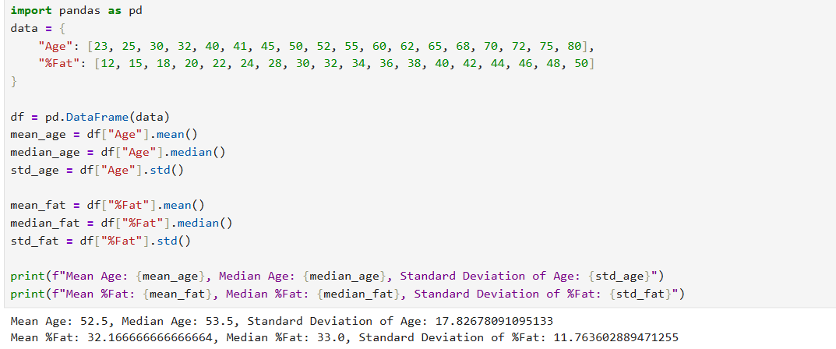

**DATASET:**

Age

23, 25, 30, 32, 40, 41, 45, 50, 52, 55, 60, 62, 65, 68, 70, 72, 75, 80

Fat

12, 15, 18, 20, 22, 24, 28, 30, 32, 34, 36, 38, 40, 42, 44, 46, 48, 50